***Example 5.5: -***

**Before Calling The Function**

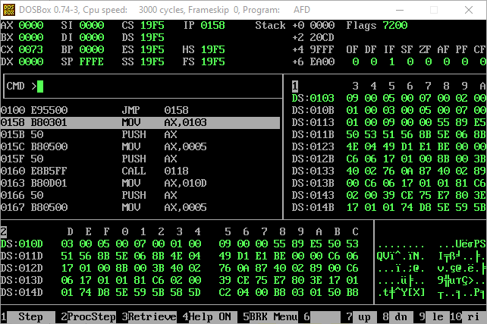

**After The Subroutine Is Called And All The Registers Used In The Sub Routine Are Pushed**

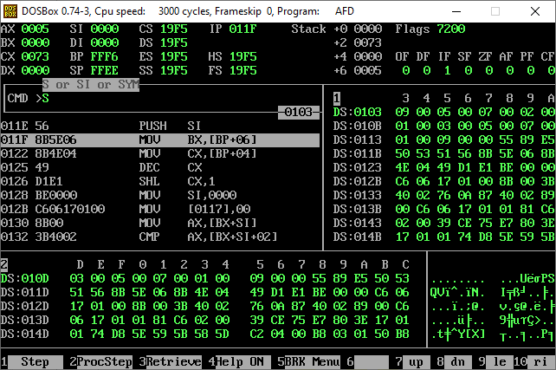

**After Popping The Registers Used In The Subroutine And Returning Back From Where It Was Called After Sorting The Data**

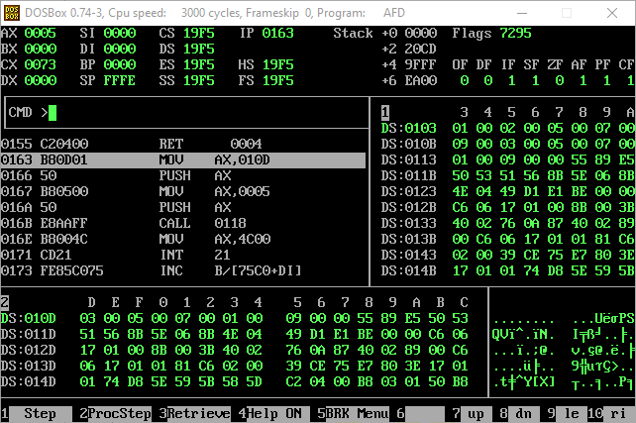

**And Same The Second Data Is Proceeded By The Same Sub Routine And Doing The Same Work Again**

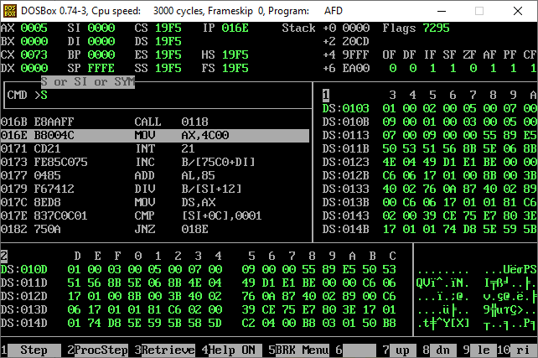

***Example 5.6: -***

**Before Calling The Subroutine, The Stack Is Used To Push The Data Address And Number Of Data**

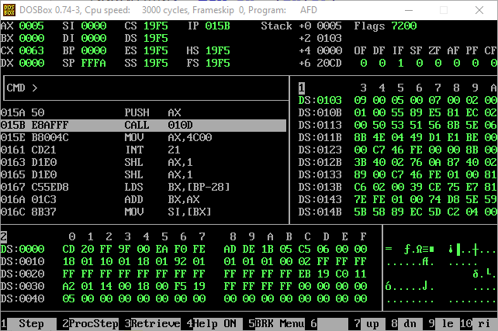

**After The Subroutine Is Called A Space In The Stack Is Made For The Local Variable In This Case It Is The Swap Flag**

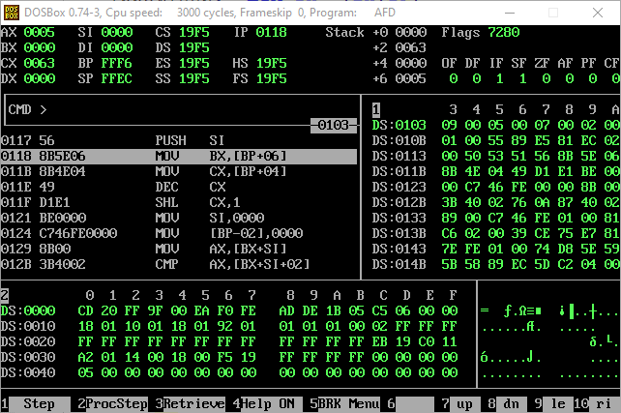

**After The Data Is Sorted**

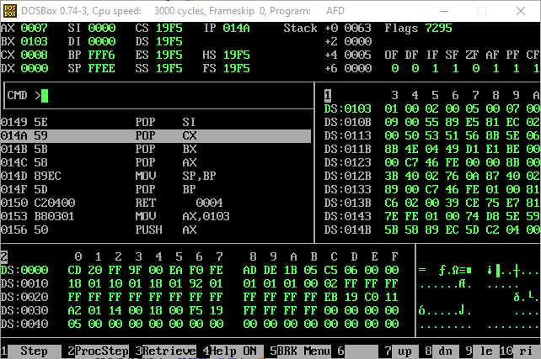

**The Registers Values Stored Before In The Stack Are Popped To Return Their Before Values And The Local Variable Is Also Destructed Here As We Previously Assigned A Place For It In The Stack And Now We Are Removing It**

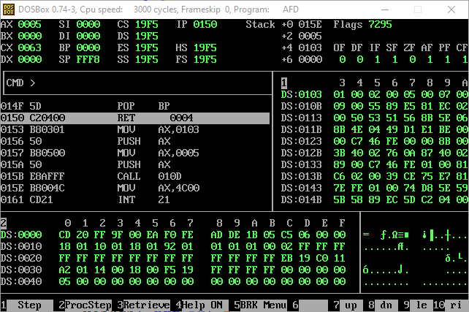

**After Returning From The Subroutine**

